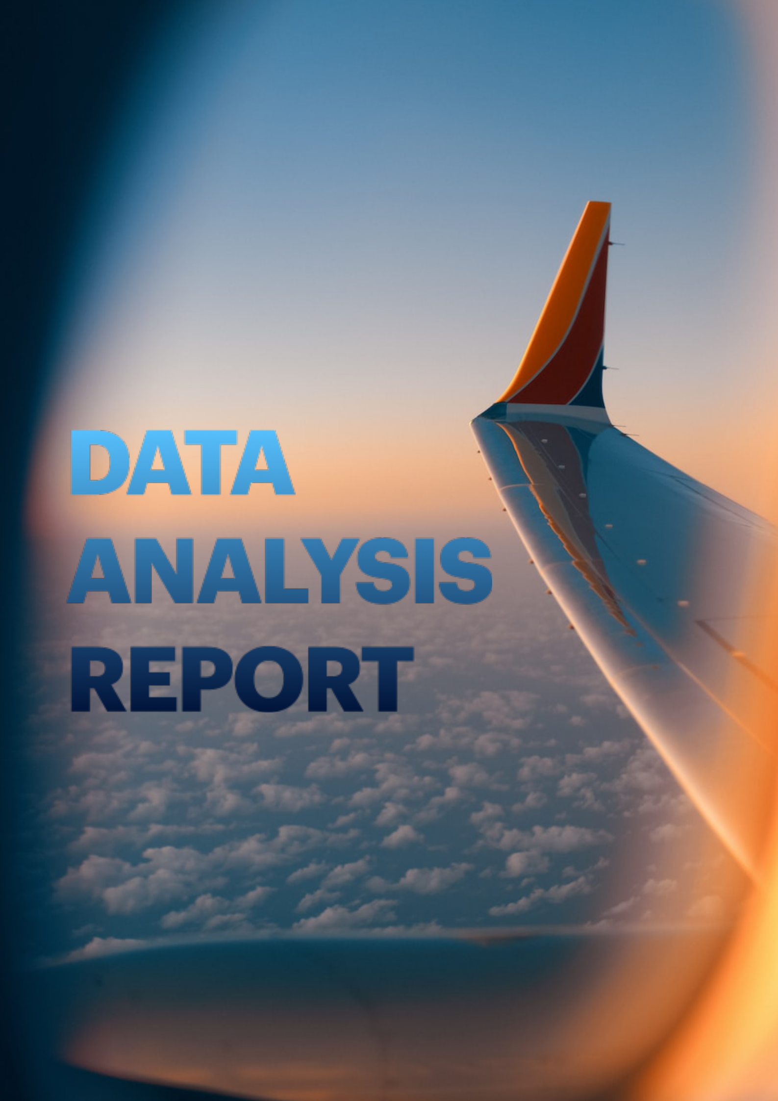

**15 January 2025**

**AIRLINES**

**Project Title:**

### Airline Route Analysis: Understanding Trends in Airline Operations.

## Introduction

Air travel is a vital mode of transportation that connects people and goods globally. Analyzing air route data can provide valuable insights into passenger demand, operational efficiency, and geographic trends. This project employs Python as the programming language and Matplotlib as the visualization tool to examine a dataset of air routes sourced from Kaggle.

## Objectives

The main goals of the project are:

* To analyze international airline routes.
* To identify the busiest routes and major international airports.
* To study the efficiency of airline routes.
* To create visual maps and charts to show the connections between airports.
* To explore passenger and cargo movement, if the data is available.

## Procedure:

1. Data Collection and preparation

2. Data Analysis

3. Visualization:

-Use tools like matplotlib to create:

-Maps or route networks

-Bar charts to show traffic volumes.

## Tools and Technologies:

Data Analysis: Python, Pandas, NumPy

Data Visualization: Matplotlib, Seaborn, Geopandas (for mapping routes)

Dataset Storage and Processing: Jupyter Notebook, CSV files

## Data Sources:

Transport Operational Data of International Biman (Kaggle)

**DATA ANALYSIS AND FINDINGS**

* User benefited from this project

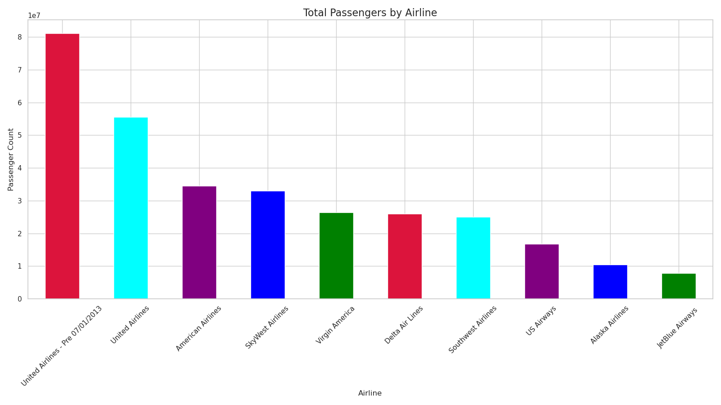

In This bar chart displays the total number of passengers for the top 10 airlines. United Airlines (Pre 07/01/2013) has the highest passenger count, followed by United Airlines and American Airlines, indicating their dominance in the market.

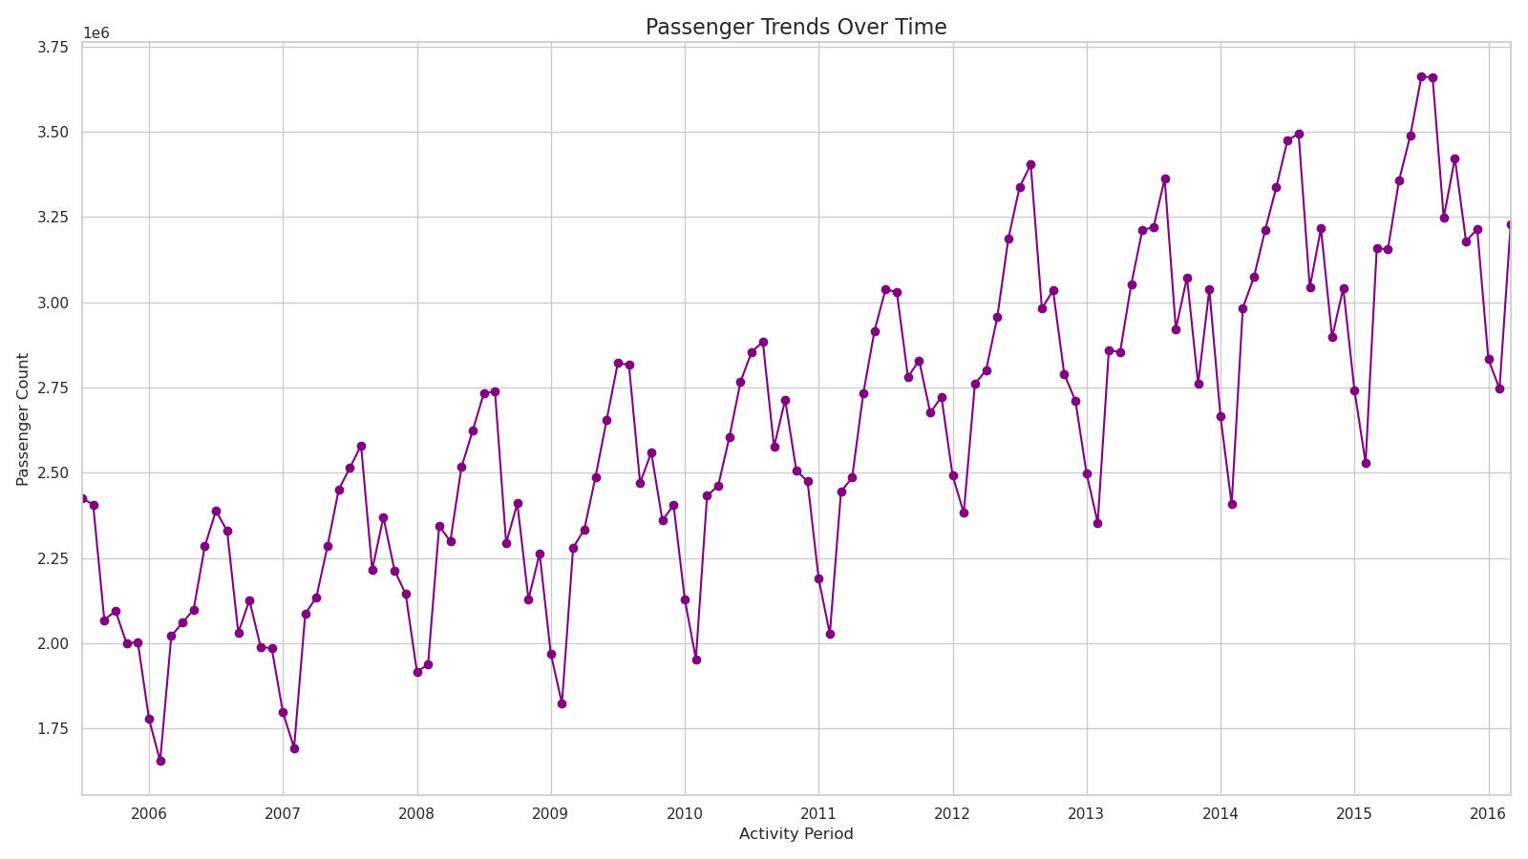

Above line graph shows passenger trends from 2006 to 2016, with a steady increase in passenger counts over time. Seasonal fluctuations are evident, but the overall trend reflects growth in airline passenger numbers during this period.

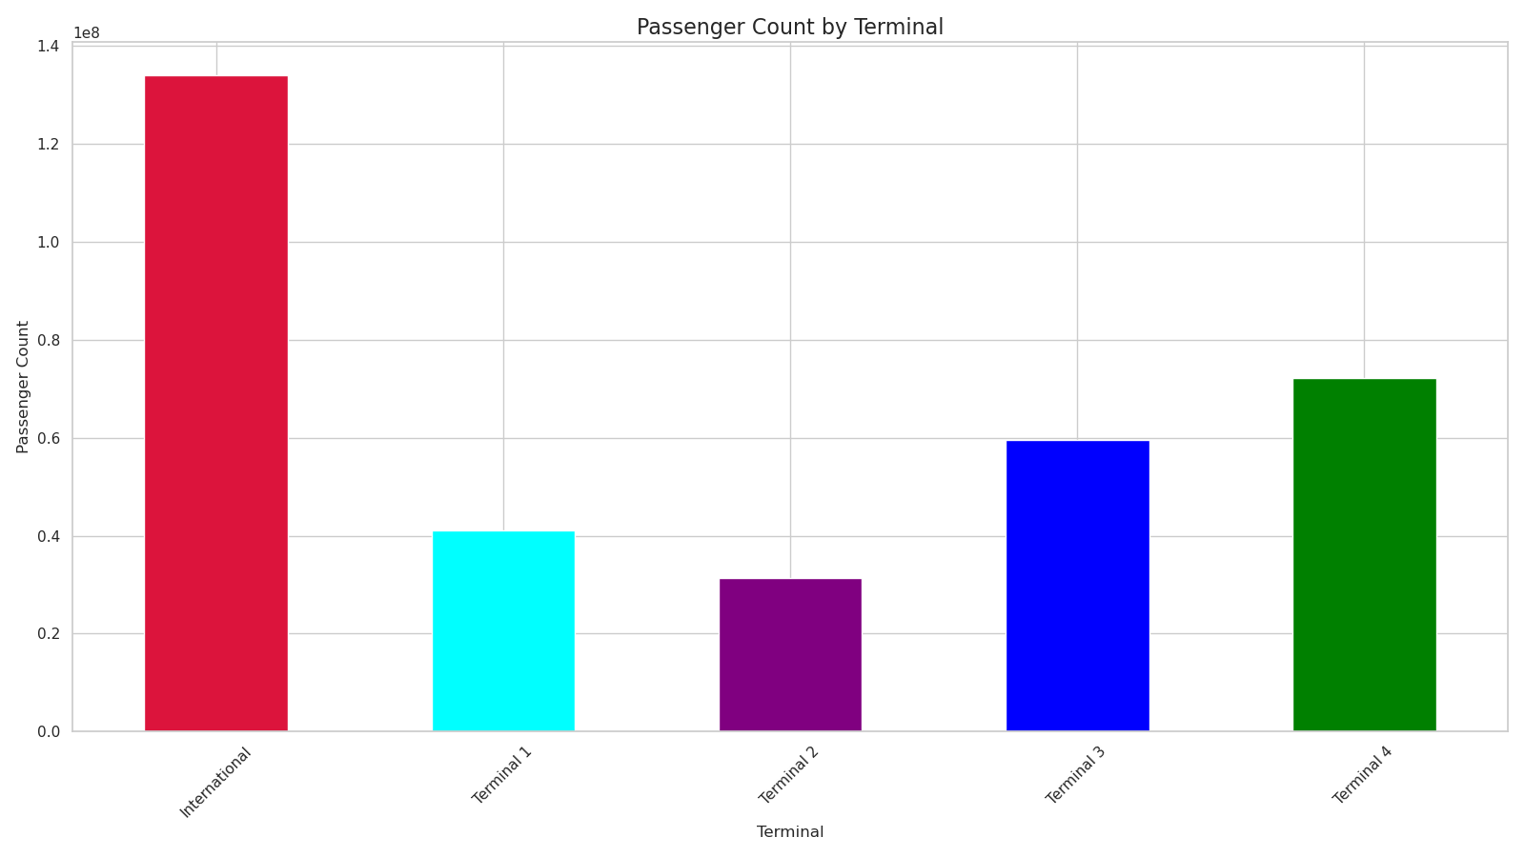

As we can see in this graph around 90% of Personal travellers are dissatisfied and on the other side Business travellers ratio is around 50-50.

Above bar chart shows that the International terminal has the highest passenger count, followed by Terminals 4, 3, 1, and 2.

* Terminal Authority benefited from this project

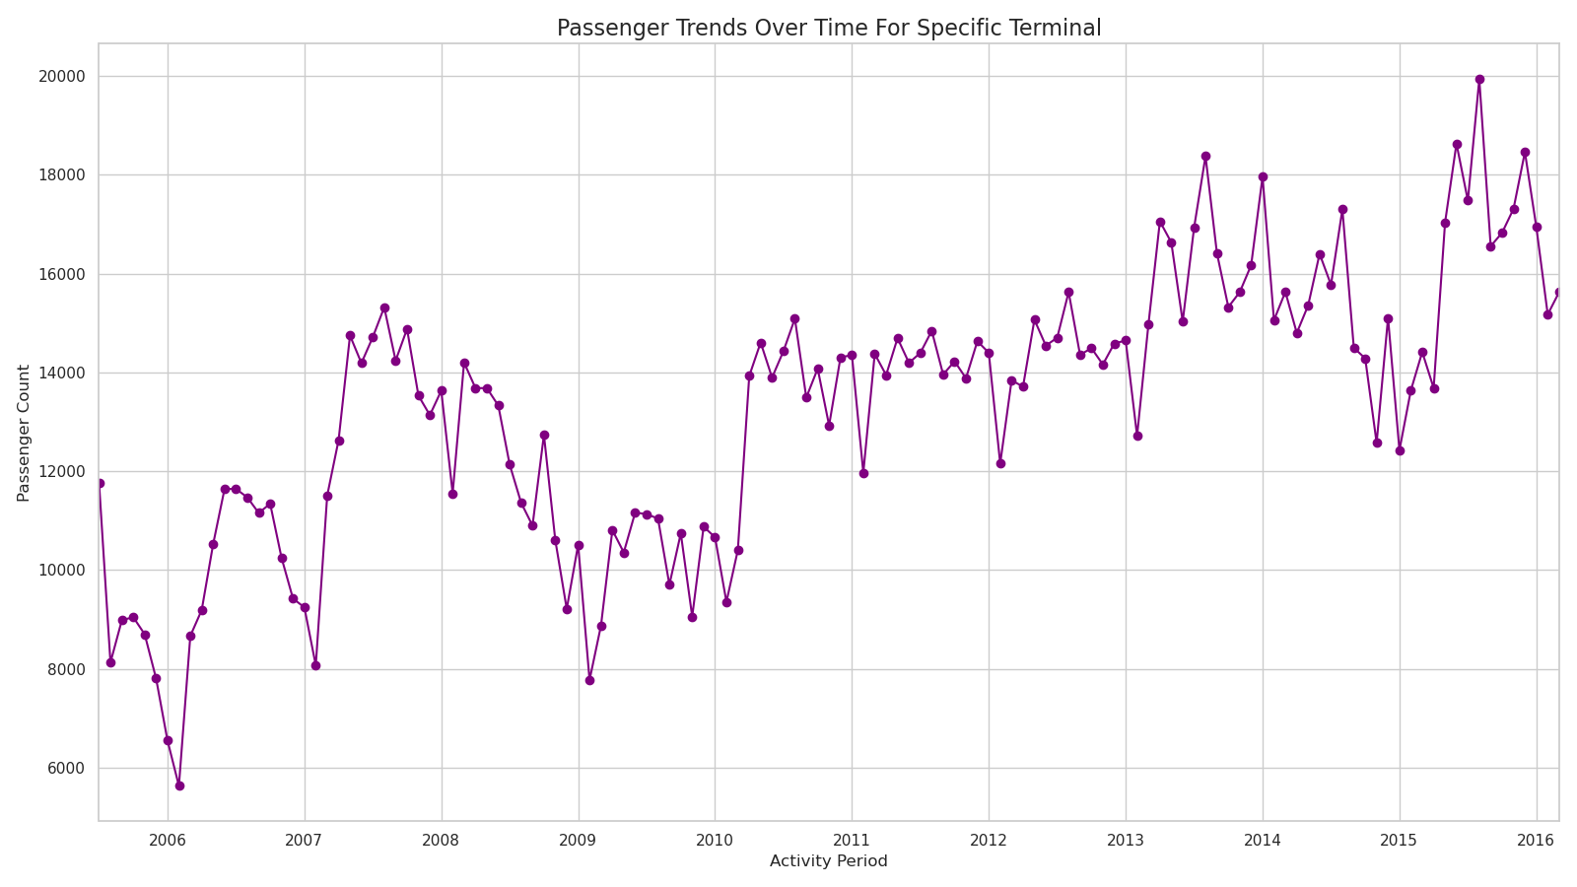

This graph displays the passenger count trends over time for a specific terminal between 2006 and 2016. It shows fluctuations in passenger numbers, with an overall increasing trend over the years, particularly after 2010, indicating growth in passenger activity.

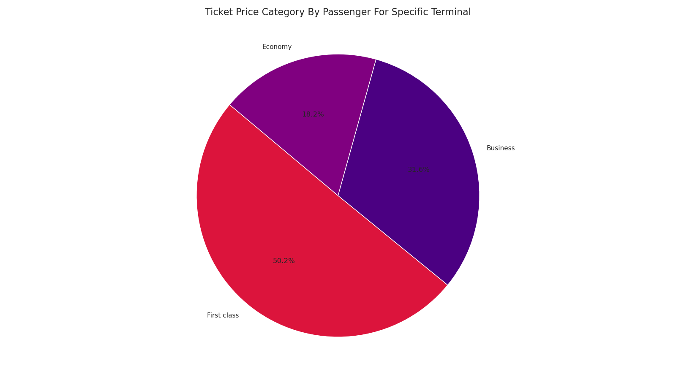

Personal travellers have highest share of ratio of

passengers who report No online boarding out of

total passengers. Unavailability of online boarding service may eﬀect the satisfaction of personal travellers, but for business travellers it look like they do not have much issue whether the online boarding service available or not.

**Findings:** By the above analysis, Mostly Business class passengers reported no Inflight wifi service, but it may not impact on their satisfaction decision, similar case in other

This pie chart shows the distribution of ticket price categories for passengers at a specific terminal, with First Class being the largest segment (50.2%), followed by Business (31.6%) and Economy (18.2%.

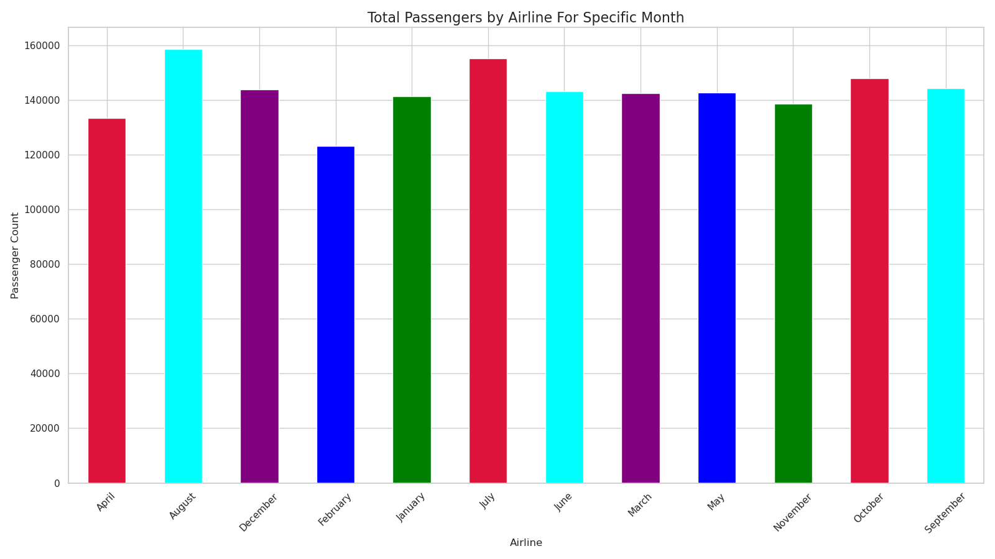

Similar as Inflight wifi service rating, Ease of online booking have low rating score, mostly below 4. Although Business travellers mostly rate 2 and 3 but also there are sort of similar count of business travellers who rate 4, but in case of personal travellers mostly rate 2 and 3 followed by 1 rating which means there is definitely personal travellers face some issue with

online booking.

**Finding:** Inflight wifi service is really concerning because all of the preferred class report low rating of 2-3 which is not consider as good rating, also there are many passengers who report no wifi as well in above data analysis, which means at many place wifi service is

This bar chart shows monthly passenger counts by airline, with most months ranging between 120,000 and 160,000 passengers, indicating seasonal variations.

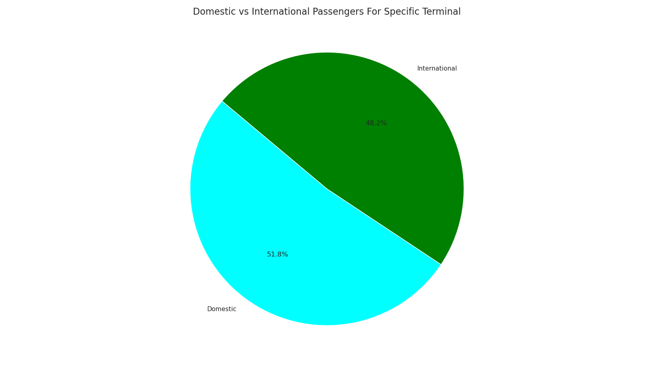

This pie chart compares the proportions of domestic and international passengers at a specific terminal. Domestic passengers account for 51.8%, slightly outnumbering international passengers, who make up 48.2%.

## Conclusion

The airline data analysis provided valuable insights into passenger behaviors and trends. These findings can help airlines optimize their flight schedules and improve resource allocation during peak times.

### Future Work

Future analyses could incorporate additional datasets, such as weather conditions and economic indicators, to understand their impact on airline traffic.

## References

* Public Airline Dataset from [Source]
* Python Pandas Documentation: https://pandas.pydata.org/
* Matplotlib Documentation: https://matplotlib.org/